
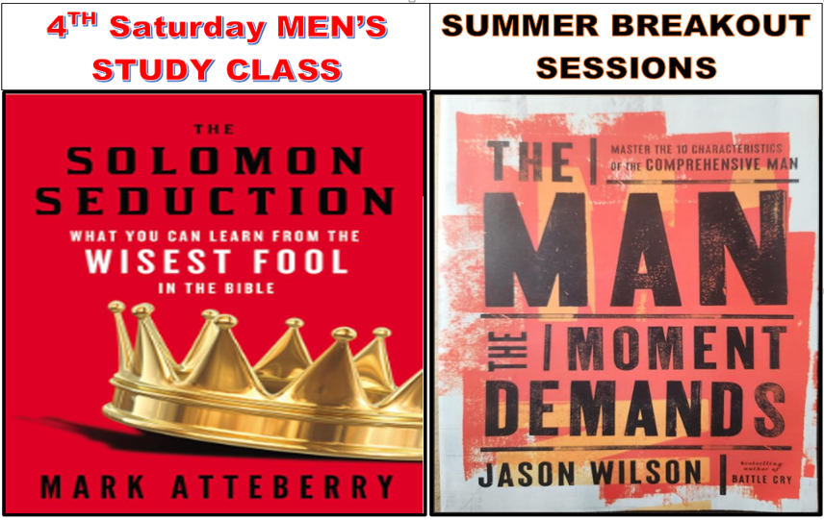
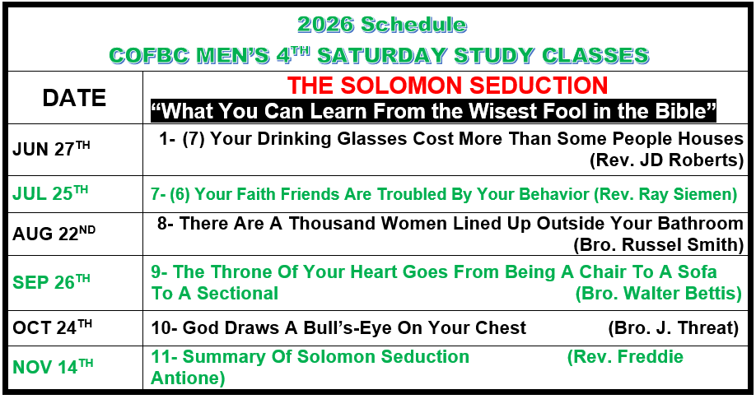
JUNE | Summer Breakout Sessions | JULY
June 3rd  Rev. R. White  1. The Initiation  2. Whatever The Moment Demands |  | July 1st  Rev. R. Sartin  6. The Lover
June 10th  Rev F. Antione  3. The Fighter |  | July 8th  Bro. D.L. Smith  7. The Nurturer
June 17th  Rev. K. Elie  4. The Provider |  | July 15th  Bro. F. Johnson  8. The Gentleman
June 24th  Rev. W. Simien  5. The Leader |  | July 22nd  Deacon R. Smith  9. The Friend
This Year's Book:  "The Man The Moment Demands"  The book may be purchased at Mardel Christian Bookstore near BEST BUY. |  | July 29th  Rev. T. Sanders  10. The Husband  11. The Father  12. The Son

